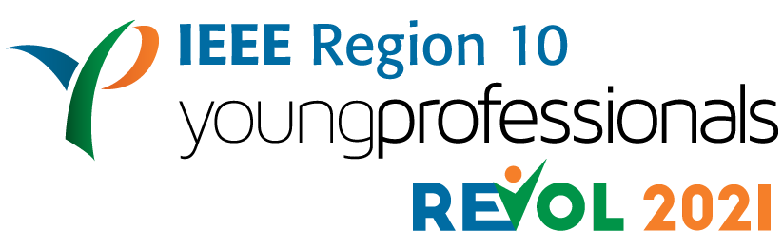

IEEE Region10 YP REVOL 2021
Declaration Form
All the winners of IEEE Region10 Young Professionals REVOL 2021 will automatically become the ambassadors of IEEE Region10 Young Professionals.
Roles & Responsibilities of IEEE Region10 Young Professionals Ambassador:
- Familiarize with the IEEE’s mission and vision, and IEEE Young Professionals goals.
- Support IEEE Region10 Young Professionals in promoting students to young professionals transitions, by encouraging new members to join IEEE as young professionals and graduating students to elevate their membership to young professionals.
- Spread awareness about the events conducted by IEEE Region10 Young Professionals through their network and social media.
IEEE Region10 Young Professionals REVOL 2021 winners will serve as IEEE Region10 Young Professionals ambassadors for a period of 6 months (July 2021 - January 2022)
---------------------------------------------------------------------------------------------------------------------
I am <please fill nominee name - IEEE membership number> from <please fill nominee IEEE section name> have read and understood all the roles and responsibilities of IEEE Region10 Young Professionals Ambassador. I confirm my availability throughout the program and I am willing to serve as an Ambassador for IEEE Region10 Young Professionals, if selected as a winner of the IEEE Region10 Young Professionals REVOL 2021.
I hereby declare that all the above mentioned statements are true and correct to the best of my knowledge.

Signature of nominee:

-----------------------------------------------
Full Name of the nominee:
Date:

